Agenda for today’s Community Soundboard:

- Introduction and Rules of Engagement (approx 5 min.)

- What is currently on the books? (approx. 10 - 20 min.)
  - Prior Zoning Code re: allowed dBA levels
  - 2018 Noise Ordinance specifications

- What is the current proposal for 2025? (approx. 10 - 20 min.)
  - Timeline of Development
  - How does the 2025 proposal differ from 2024’s proposal?
  - What updates have there been?

- What is the science behind how sound travels? (approx. 10 -20 min.)
  - How is it measured?
  - How do distance and matter affect perception and measurement of sound?

- What alternative solutions have been discussed? (approx. 1 hr)
- Thoughts gathered by WCCA (approx 15 - 20 min.)
- Current thoughts, ideas, solutions, concerns (Community Discussion & Feedback - approx. 45 min.)

- What are some tactics to make May 13th’s Public Hearing as effective as possible? (approx. 15 - 20 min.)
- Persuasive communication tactics
- What are the rules for a Public Hearing in New York State?

- What do we want for our community / where are we going?
- What does a healthy community look like for us ? (last 30 min. for Community Discussion & Feedback).

Rules of Engagement for Community Conversation:

- Be An Active Listener: Pay attention to what others are saying when they are speaking and give them your full attention. Consider what they are saying and try not to craft a response or rebuttal while they are speaking, as this detracts from giving them your full attention.

- One Person At A Time: In respect to each other and crafting a respectful, productive environment, please allow one person to speak at a time. We will do our best to make sure everyone gets a chance to speak and ensure everyone feels heard.

- Take Space, Leave Space: If you know you are the type of person who has a lot of feedback, if you notice you are speaking frequently, consider stepping back to offer space to someone who may not otherwise feel comfortable taking it. Likewise, if you know you are a person who may give more space to others, consider allowing yourself to take some! We want to make sure we are respectful of everyone’s time and boundaries.

- Focus on the Issues: No personally directed insults or attacks. Criticisms should be based on the issues and facts. We are all in local community with each other, and will remain this way. Our aim is to be solution and community oriented, and to be mindful of the goals of the conversation. Be mindful you are not using this time solely to vent - stay constructive.

- Focus on the Solutions: Acknowledge that your fellow community members can and will have differing opinions. The goal is not to agree on everything, but to find actionable solutions that will meet our needs as a community as best we are able. Where do we find common ground? What are clarifying questions we can ask each other to aid us in that process?

- Stay Open-Minded: In looking for solutions, be open minded to new or different information. It is always possible that information has not been clarified, has been misunderstood, or has not been presented.

Zoning Code: https://ecode360.com/109256

§260-29. General Performance Standards: No use shall be permitted and/or maintained that does not conform to the following standards of use, occupancy, and operation, in addition to all relevant provisions of other local, state and federal laws, rules or regulations.

- Noise.
- No person shall operate or cause to be operated any source of sound in such a manner as to create a sound level which exceeds the limits set forth for the receiving land use category stated below when measured at or within the property boundary of the receiving land use.

Receiving Land Use Category: | Time: | Sound Level Limit (dBA)
Residential Districts R8, R5, R3, R1.5, HR, and PRD | 7:00am - 7:00pm  7:00pm - 7:00am | 57dBA  53dBA
Commercial Districts HC, NC1, and NC2 | 7:00am - 9:00pm  9:00pm - 7:00am | 64dBA  60dBA
Industrial Districts LI/SLI | 7:00am - 9:00pm  9:00pm - 7:00am | 68dBA  63dBA

- For any source of sound which emits a pure tone, a discrete tone or impulsive sound, the maximum sound limits set forth above shall be reduced by five dBA.
- For noises created and measured at outdoor locations within the Hamlet Commercial (HC) and Neighborhood Commercial (NC) Districts, the sound level shall not exceed the above limits for those districts when measured at a point 10 feet or greater from the sound source or at a property boundary.
Chapter 139. Noise
[HISTORY: Adopted by the Town Board of the Town of Woodstock 4-24-2018 by L.L. No. 1-2018. Amendments noted where applicable.]

§ 139-1. Legislative intent.
The making and creating of disturbing, excessive, or offensive noises in the Town is a
condition which has persisted, and the level and frequency of occurrences of such noises continues to increase. These noise levels are a detriment to the public health, comfort, convenience, safety, and welfare of the citizens. Every person is entitled to an environment in which disturbing, excessive, or offensive noise is not detrimental to his or her life, health, or enjoyment of property. This chapter is to be construed liberally, but it is not intended to be construed so as to discourage the enjoyment by residents of normal, reasonable and usual activities.

§ 139-2. Prohibited acts.
- No person, with the intent to cause public inconvenience, annoyance or alarm, or or recklessly creating a risk thereof, shall cause, suffer, allow or permit to be made unreasonable noise. For purposes of this chapter, unreasonable noise is any disturbing, excessive, or offensive sound that disturbs a reasonable person of normal sensitivities.

- The following acts are declared to be prima facie evidence of a violation of this chapter. This enumeration shall not be deemed exclusive.

- Any unnecessary noise from any source between the hours of 11:00 p.m. and 7:00 a.m. the following day.
- Noise from a dog or other pet animal that is continuous and exceeds 15 minutes.
- Noise from a burglar alarm or other alarm system of any building or vehicle which is continuous and exceeds 15 minutes.
- Excessive or unreasonable level of noise from any live music or sound reproduction system, operating or playing any radio, portable radio or tape player, television, tape deck or similar device that reproduces or amplifies sound in such a manner as to be heard over any property line.
- The erection, including excavation, demolition, alteration or repair of any building other than between 7:00 a.m. and 9:00 p.m., except in case of a public safety emergency.
- The operation of power equipment in residential zones outdoors between the hours of 9:00 p.m. and 7:00 a.m. the following day, and on weekends between 9:00 p.m. and 8:00 a.m.
- The sounding of any horn or signaling device of an automobile, motorcycle or other vehicle for any unnecessary or unreasonable period of time. The making of improper noise or disturbance or operating an automobile or motorcycle in such a manner as to cause excessive squealing or other excessive noise of the tires.

§ 139-3. Exceptions.
The provisions of this chapter shall not apply to the following acts:

- The emission of sound for the purpose of alerting persons to the existence of an emergency;
- Noise from municipally sponsored celebrations or events;
- Noise from individually sponsored events where a permit for public assembly or other relevant permission has been obtained from the Town;
- The operation or use of any organ, radio, bell, chimes or other instrument, apparatus, or device by any church, synagogue, or school licensed or chartered by the State of New York, provided such operation or use does not occur between the hours of 10:00 p.m. and 8:00 a.m.;
- Noise generated by the installation and maintenance of utilities.

§ 139-4. Penalties for offenses.
Any person who violates any provision of this chapter shall be guilty of a violation and shall be subject to a fine not to exceed $250 for each offense. The Town may also seek injunctive relief to prevent the continued violation of this chapter.

Local Law No. ?? of the Year 2024
Be it enacted by the Town Board of the Town of Woodstock, NY as follows:

§ Legislative intent.
The making and creating of disturbing, excessive, or offensive noises in the Town is a condition which has persisted. These noise levels can be a detriment to the public health, comfort, convenience, safety, and welfare of the citizens. Every person is entitled to an environment in which disturbing, excessive, or offensive noise is not detrimental to his or her life, health, or enjoyment of property. The chapter is to be construed liberally, but it is not intended to be construed so as to discourage the enjoyment by residents of normal, reasonable and usual activities.

§ Prohibited acts.
- No person, with the intent to cause public inconvenience, annoyance or alarm, or recklessly creating a risk thereof, shall cause, suffer, allow or permit to be made unreasonable noise. For purposes of this chapter, unreasonable noise is any disturbing, excessive, or offensive sound that disturbs a reasonable person of normal sensitivities.

- The following acts are declared to be prima facie evidence of a violation of this chapter. This enumeration shall not be deemed exclusive.
- Any unnecessary noise from any source between the hours of 9 p.m. and 7:00 a.m. the following day.
- Noise from a dog or other pet animal that is continuous and exceeds 15 minutes.
- Noise from a burglar alarm or other alarm system of any building or vehicle which is continuous and exceeds 15 minutes.
- Excessive or unreasonable level of noise from any live music or sound reproduction system, operating or playing any radio, portable radio or tape player, television, tape deck or similar device that reproduces or amplifies sound. For the purpose of this law, a prolonged decibel reading of 70, unless otherwise permitted as a special event, is considered unreasonable.
- The construction, including excavation, demolition, alteration or repair of any building other than between 7:00 a.m. and 9:00 p. m., except in case of a public safety and emergency.
- The operation of power equipment outdoors between the hours of 9:00 p.m. and 7:00 a.m. the following day, and on weekends between 9:00 p.m. and 8:00 a.m.
- The sounding of any horn or signaling device of an automobile, motorcycle or other vehicle for any unnecessary or unreasonable period of time.
- The making of improper noise or disturbance or operating an automobile or motorcycle in such a manner as to cause excessive squealing or other excessive noise of the tires.

§ Allowed acts - regarding outdoor music
- Ambient outdoor music (as defined in DEFINITIONS section of law) is permitted from 11am to 9pm on any day of the week, provided:

1. it does not exceed 65 decibels at the property line.
2. it does not cause any nuisance to residential neighbors.

- Amplified live outdoor music events will be limited to the following conditions:

1. All venues will be limited to two outdoor events per week, on Friday and Saturday. A
third event may be added on the Sunday of holiday weekends (as defined in
DEFINITIONS section of law).
2. Limited to the hours of 12 pm and 9 pm for a maximum of 3 hours.
3. Cannot exceed 70 decibels as measured from the property line of the venue.
4. Venues must apply for a yearly permit for outdoor events.

- Special events (as defined in DEFINITIONS section of law) are allowed, provided a permit is obtained from an Event Committee (as defined in DEFINITIONS section of law). The Committee will consider the following items in issuing permits:

1. Time of day/night and duration, limited to between 12 pm and 9 pm for a
maximum of 5 hours
2. Location
3. Potential noise level with a maximum of 75 decibels
4. Crowd size
5. Any other conditions which may affect the community.
6. Maximum of 5 events per year, per venue.

§ Exceptions.
The provisions of this chapter shall not apply to the following acts:
- The emission of sound for the purpose of alerting persons to the existence of an emergency;
- Noise from municipally sponsored celebrations or events, however, Town sponsored events will submit an application with the “Event Committee” for a courtesy review.
- Noise from individually sponsored events where a permit for public assembly or other relevant permission has been obtained from the Town;

- The operation or use of any bell, chimes or other instrument, by any church, synagogue, or school licensed or chartered by the State of New York provided it is for a duration no longer than 10 minutes.

§ Penalties for offenses.
Any person who violates any provision of this chapter shall be guilty of a violation and shall be subject to a fine not to exceed $250 for the first offense. The second offense with a 3 month period will be a fine not to exceed $750, the third within 6 months not to exceed $1500. and each additional within a year not to exceed $1500. The Town may also seek injunctive relief to prevent the continued violation of this chapter. In addition, after with the third offence, the Event Committee will review to consider revoking the venue’s amplified live outdoor music events permit and/or the venue’s special events permit for one calendar year from third infraction.

§ Definitions.
Ambient outdoor music- live or recorded music which is intended as background music for patrons who are dining, drinking or otherwise socializing and which allows for conversations that do not require raising one’s voice to be heard. May not be more than 65 DB at the venue’s property line.

Amplified live outdoor music event- louder music which is presented with the intention of being an audience’s primary focus and which does not exceed 70 DB measured from the property line of the venue. Venues must obtain a general yearly permit from the Event Committee in order to have these events.

Decibel- the unit used to measure sound level. For the purpose of this law, decibels may be measured by meters specially designed to measure sound or by an app on a device such as a smart phone, that is designed to measure sound. Decibel readings will be taken from the property line over a period of one minute.

Holiday weekend- the weekend closest to the following federal holidays: Memorial Day, Independence Day, Juneteenth, Labor Day and Indigenous Peoples’ Day.

Prolonged reading- a decibel reading where a level is maintained for one minute.

Reasonable person- represents a composite of the community’s judgement as to how a typical member should behave.

Special event- an outdoor musical event that is specifically permitted by the Event
Committee.

Unnecessary or excessive noise- loud sound which either annoys, disturbs, injures or
endangers the comfort, repose, health, peace and safety of a reasonable person of normal sensibilities.

Woodstock Event Committee - committee created by separate resolution of the
Woodstock Town Board to review applications and issue permits for amplified live outdoor music events and special events. The Town Board may appoint an existing board or committee, such as the Planning Board, to act as an event committee.

Local Law No. 1 of the Year 2025
Be it enacted by the Town Board of the Town of Woodstock, NY as follows:

§ 139-1 Legislative intent.
The making and creating of disturbing, excessive, or offensive noise or sounds in the Town can be a detriment to the public health, comfort, convenience, safety, and welfare of the citizens. Every person is entitled to an environment in which disturbing, excessive, or offensive noise or sound is not detrimental to his or her life, health, or enjoyment of property. The chapter is to be construed liberally, but it is not intended to be construed so as to discourage the enjoyment by residents of normal, reasonable and usual activities.

The Town of Woodstock, NY endeavors to allow its citizens adequate means of expression and to promote the economic welfare of the business community, while protecting the town and its citizens from a proliferation of disturbing or excessive sounds, as defined in this article, that would adversely impact the aesthetics of the community and threaten the health, safety and welfare of members of the community. In accordance with the values as applied in Woodstock’s 2018 Comprehensive Development Plan, which states:

“Woodstock is defined in many ways by its unique artistic and creative character. It is a large part of the community’s personality and identity. Supporting the arts and cultural institutions has been
identified as a high priority by the Woodstock Comprehensive Plan Community Survey respondents. Our lively arts and cultural venues and events contribute to the town’s identity as Colony for the Arts, and provide strong support for the town’s economy...”

This ordinance seeks to protect the community's health and safety while respecting the art, culture, performing arts & music that is integral to Woodstock’s character. Clear and enforceable regulation of sounds and noise will have a positive impact on safety, police enforcement, and the wellbeing of the community including those attributes physical, emotional, and economic.

§ 139-2 Prohibited acts.
- No person, with the intent to cause public inconvenience, annoyance or alarm, or recklessly creating a risk thereof, shall cause, suffer, allow or permit to be made unreasonable sound. For purposes of this chapter, unreasonable sound is any disturbing, excessive, or offensive sound that disturbs a reasonable person of normal sensitivities.

- The following acts are declared to be prima facie evidence of a violation of this chapter. This enumeration shall not be deemed exclusive.
- Any unnecessary sound from any source between the hours of 9 p.m. and 7:00 a.m. the following day.
- Sound from a dog or other pet animal that is continuous and exceeds 15 minutes.

- Sound from a burglar alarm or other alarm system of any building or vehicle which is continuous and exceeds 15 minutes.
- Excessive or unreasonable level of sound from any live music or sound reproduction system, operating or playing any radio, portable radio or tape player, television, tape deck or similar device that reproduces or amplifies sound and causes nuisance or distress to neighbors unless it is permitted under Allowed Acts.
- The construction, including excavation, demolition, alteration or repair of any building other than between 7:00 a.m. and 9:00 p.m., except in case of a public safety and emergency.
- The operation of power equipment outdoors between the hours of 9:00 p.m. and 7:00 a.m. the following day, and on weekends between 9:00 p.m. and 8:00 a.m.
- The continuous sounding of any horn or signaling device of an automobile, motorcycle or other vehicle for any unnecessary or unreasonable period of time.
- The making of improper sound or disturbance or operating an automobile or motorcycle in such a manner as to cause excessive squealing or other excessive sound of the tires.

§ 139-3 Allowed acts - regarding outdoor music
- Ambient outdoor music (as defined in DEFINITIONS section of law) is permitted from 7am to 9pm on any day of the week, provided:
1. it does not exceed 65 decibels at the property line nearest to the closest residence.

- Amplified live outdoor music (as defined in DEFINITIONS section of law) events will be subject to the following conditions:

1. All venues may present outdoor events on Fridays and Saturdays. A third event may be
added on the Sunday of Memorial Day and Labor Day weekends, plus events may be held on
Independence Day, Juneteenth and Indigenous People’s Day.
2. Events may be presented between 12 pm and 9 pm for a maximum of 3 hours. In
addition, throughout the months of July and August, Saturday events may last until 10 pm for a
maximum of 4 hours.
3. Cannot exceed 70 decibels as measured from the property line of the venue that is
nearest to the closest residence.
4. Venues must apply for a yearly permit from the town clerk to present outdoor events.
5. Sound checks are permitted (as defined in DEFINITIONS section of law) and are not
included in the mandated performance time allowance.

- Special events (as defined in DEFINITIONS section of law) are allowed, provided a permit is obtained from the town clerk or an Event Committee (as defined in DEFINITIONS section of law). The following information will be considered in issuing permits:

1. Time of day/night and duration, which may occur between 12 pm and 9 pm for a
maximum of 5 hours. Should the special event fall on a Saturday during the months
of July and August it will be allowed until 10pm with a maximum of 5 hours,
2. Location
3. Potential sound level with a maximum of 75 decibels
4. Crowd size
5. Any other conditions which may affect the community.
6. Maximum of 5 events per year, per venue.

- Busking on the sidewalks of the Hamlet Commercial Zone and on the Village Green is allowed subject to the discretion of the property or business owners where the performance is taking place
- The town sanctioned drum circle on the village green is allowed on Sundays from 4pm-6pm as agreed upon by the Woodstock Dutch Reform Church.

§ 139-4 Exceptions.
The provisions of this chapter shall not apply to the following acts:
- The emission of sound for the purpose of alerting persons to the existence of an emergency.
- Sound from municipally sponsored celebrations or events, however, Town sponsored events may submit an application with the “Event Committee” for a courtesy review.
- Sound from individually sponsored events where a permit for public assembly or other relevant permission has been obtained from the Town.
- The operation or use of any bell, chimes or other instrument, by any church, synagogue, or school licensed or chartered by the State of New York provided it is for a duration no longer than 10 minutes.
- Expressions of First Amendment right to freedom of speech.

§ 139-5 Penalties for offenses.
Penalties for offenses shall be enforced by the Woodstock Police Department. WPD will accordingly issue tickets. Any person who violates any provision of this chapter shall be guilty of a violation and shall be subject to a fine of $250 for the first offense. The second offense within a 3-month period will be a fine of $750, the third within 6 months a fine of $1500. and each additional within a year a fine of $1500. The Town may also seek injunctive relief to prevent the continued violation of this chapter. In addition, with the third offence from a music venue, the Event Committee will review to consider revoking the venue’s amplified live outdoor music events permit and/or the venue’s special events permit for a twelve month period from third infraction. Be it noted that a verified act of violation shall be considered a single offense regardless of the number of complainants on a given incident.

§ 139-6 Definitions.
Ambient outdoor music- live or recorded music which is intended as background music for
patrons who are dining, drinking or otherwise socializing and which allows for conversations
that do not require raising one’s voice to be heard. May not be more than 65 DB at the venue’s
property line that is nearest to a residence.

Amplified live outdoor music event: Louder music which is presented with the intention of
being an audience’s primary focus and which does not exceed 70 DB, or 75 DB for Special
Events, measured from the property line of the venue that is nearest to a residence. Venues
must obtain a general yearly permit from the town clerk or the Event Committee in order to
have these events.

Busking: The activity of playing music for tips or voluntary donations in a public place that is
not associated with a music venue.

Decibel: The unit used to measure sound level. For the purpose of this law, decibels may be
measured by meters specially designed to measure sound or by an app on a device such as a
Smart Phone, that is designed to measure sound. Decibel readings will be taken from the
property line area closest to the nearest residences, as an average over a period of one minute.

Prolonged reading: A decibel reading where a level is maintained for one minute.

Reasonable person: Represents a composite of the community’s judgment as to how a typical
member should behave.

Sound check: The setting of microphone and amplifier levels preceding a show. The sound
check may not exceed one hour and may not exceed the allowable decibel limit.

Special event: An outdoor musical event that is specifically permitted by the Event
Committee.

Unnecessary or excessive sound: Sound which either annoys, disturbs, injures or endangers
the comfort, repose, health, peace and safety of a reasonable person of normal sensibilities,
that is not necessary for safety and well-being.

Woodstock Event Committee: Committee created by separate resolution of the Woodstock
Town Board to review applications and issue permits for amplified live outdoor music events
and special events. The Town Board may appoint an existing board, committee, or department,
such as the Planning Board, Building Department, or Town Clerk’s office, to act as an event
committee.

Severability.
If any clause, sentence, paragraph, section, article, chapter or part of this local law now or
through supplementation shall be adjudged by any court of competent jurisdiction to be invalid,
such judgment shall not affect, impair or invalidate the remainder thereof but shall be confined
in its operation to the clause, sentence, paragraph, section, article, chapter or part thereof
directly involved in the controversy in which such judgment shall have been rendered.

Effective Date.
This Local Law shall take effect upon being filed in the office of the New York Secretary of State.

How is sound measured? :
From the National Institute on Deafness:
“We measure sound intensity (also referred to as sound power or sound pressure) in units called decibels. Decibels (dB) are named in honor of Alexander Graham Bell, the inventor of both the telephone and the audiometer. …

Decibels are different from other familiar scales of measurement. While many standard measuring devices, such as rulers, are linear, the decibel scale is logarithmic. This kind of scale better represents how changes in sound intensity actually feel to our ears. To understand this, think of a building that is 80 feet tall. If we build up another 10 feet, the building will be 12.5 percent taller, which would seem just slightly taller to us; this is a linear measurement. Using the logarithmic decibel scale, if a sound is 80 decibels, and we add another 10 decibels, the sound will be ten times more intense, and will seem about twice as loud to our ears. …

Sometimes we use different versions of decibels. A-weighted decibels, or “dBA,” are often used when describing sound level recommendations for healthy listening. While the dB scale is based only on sound intensity, the dBA scale is based on intensity and on how the human ear responds”

How does sound travel? :
From “Understanding Sound” by David Abbott:
“As you move away from a sound source, the sound gets quieter- especially when you are outdoors. This is not surprising. Much like light, sound spreads out as it travels away from the source. Unless there are surfaces for the sound to reflect from, the sound’s intensity becomes less and less as you get further from the source. … If you’ve ever used a can of spray paint, you know that distance is important- the closer you are to the nozzle, the more concentrated the paint stream is. Hold the can close to the surface you’re painting, you get a small spot of really thick paint. Hold the can further away and the same amount of paint gives a thinner coat that covers a larger area.
Suppose you squirt a dose of paint on a wall. You then deliver the same dose of paint from twice as far away and compare. How much larger is the new spot? How thick is the paint? What did you answer? Twice the area? Half as thick? If you did, you got the answers wrong! Remember that area is length times width. Since the new paint spot is both twice as wide and twice as high as the original, it covers four times the area. As a result, the paint is only one quarter as thick as before. At triple the initial distance, the paint spot has nine times the original size and the paint is only one ninth as thick, and so on. In math speak, the concentration of the paint follows an inverse square law. Sound radiating into open space works the same way. As you get farther and farther from the source, the power put out by the sound source gets spread over a larger and larger area. As a result, the sound intensity follows an inverse square law.”

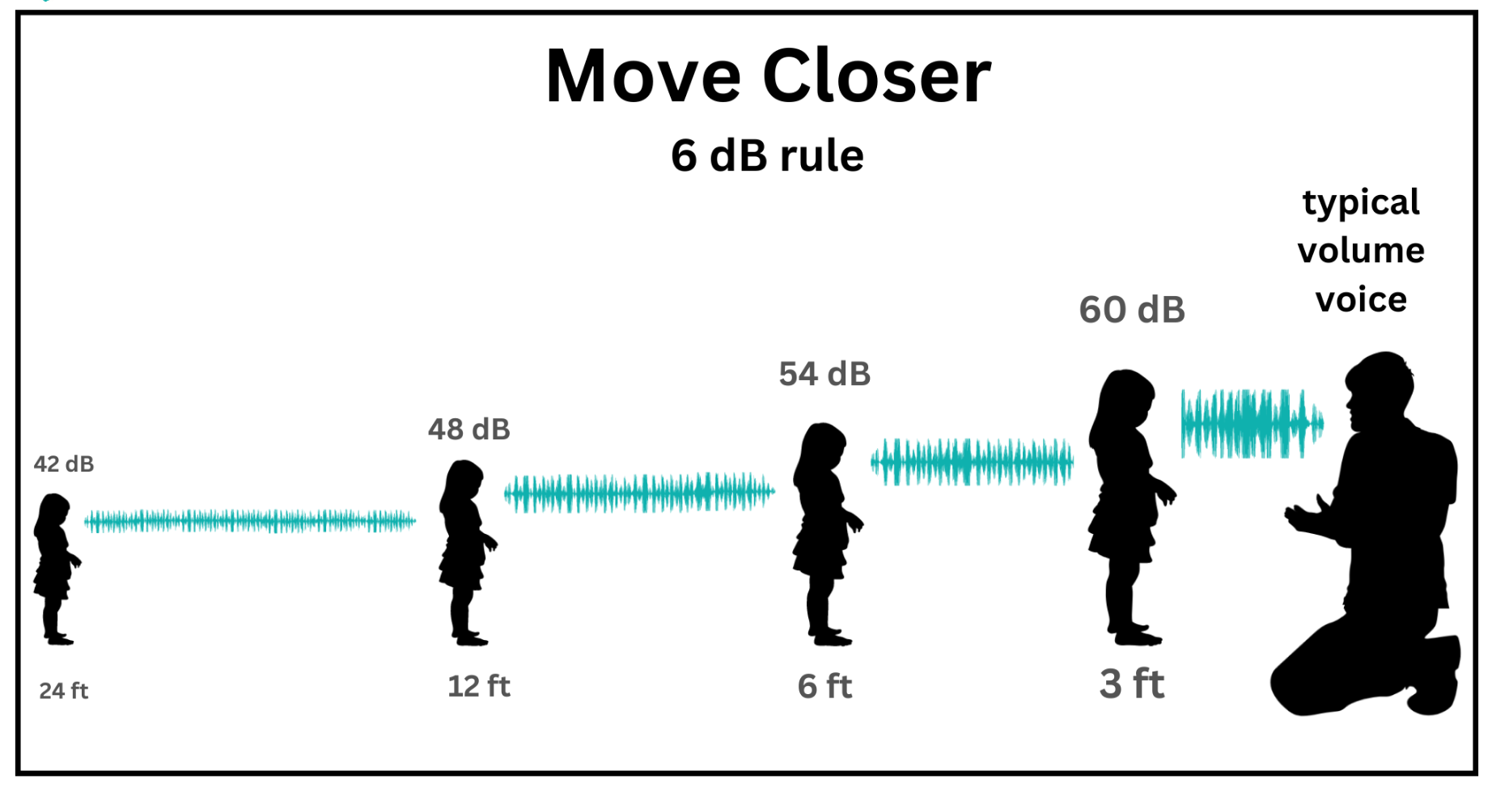
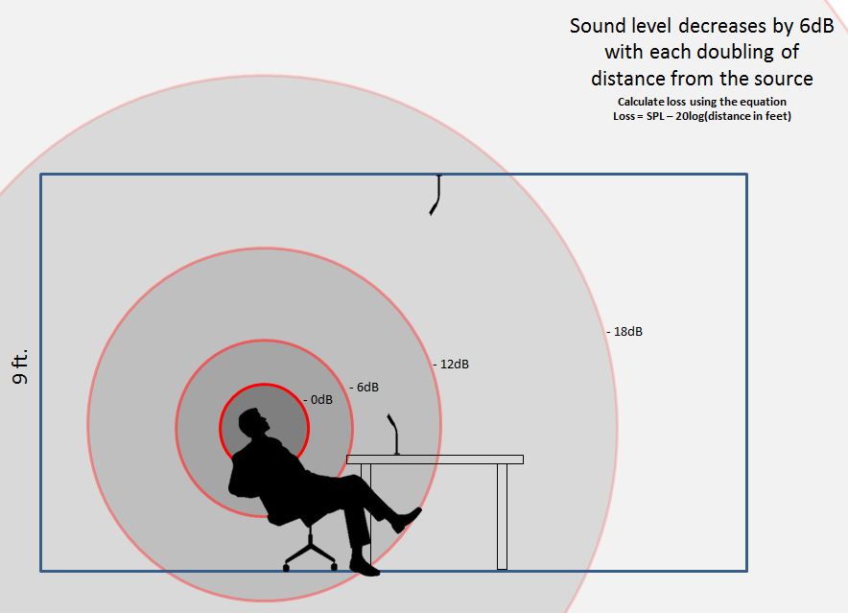
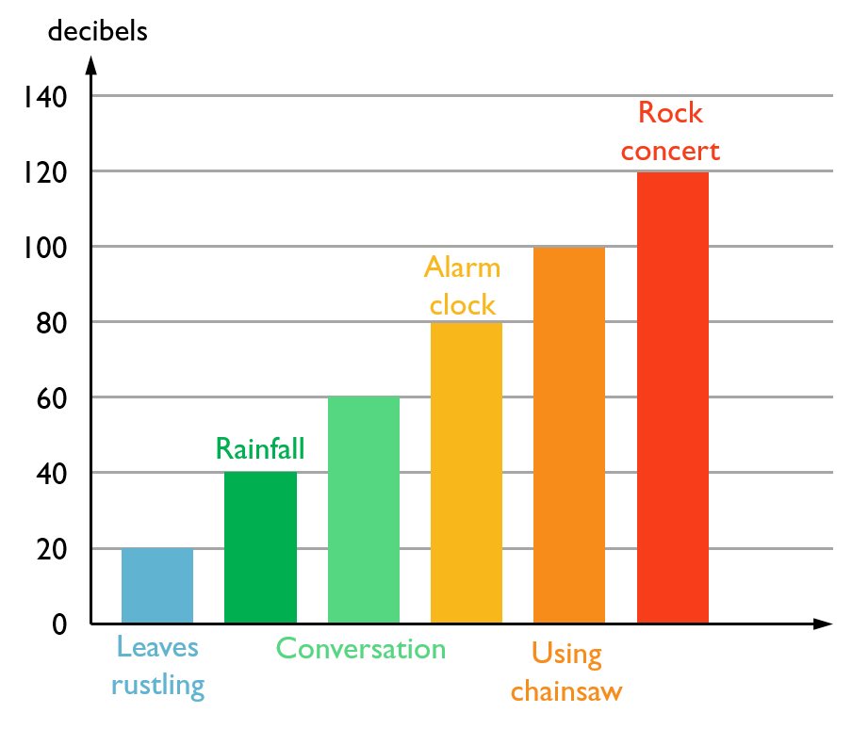

From the New York Committee on Open Government:

“The OML provides the public with the right to attend meetings of public bodies, but it is silent concerning the ability of members of the public to speak or otherwise participate. Although public bodies are not required to permit the public to speak at their meetings, many have chosen to do so. In those instances, we have advised that a public body should do so by adopting reasonable rules that treat members of the public equally. If a public body is leveraging “extraordinary circumstances videoconferencing” pursuant to POL § 103-a to conduct its meeting, the public body must provide the same opportunity for members of the public to view the meeting (and participate, if such body permits public participation), both by remote technology or in person, in real time. Public bodies are required to allow meetings to be photographed, broadcast, webcast or otherwise recorded as long as the equipment used to do so is not disruptive or obtrusive. If the public body adopts rules regarding such activities, they must be reasonable and conspicuously posted, and be provided to those in attendance upon request. See POL § 103(d).”

From “Conducting Public Meetings and Public Hearings” from the NYS Department of State Division on Local Gov’t:

“CONDUCTING A PUBLIC HEARING The following is a list of steps and suggestions to help in preparing for a public hearing.

1. Determine Hearing and Notice Requirements — The board should consult with its attorney in order to determine what hearing and notice requirements must be satisfied, as well as the possible necessity of sending special notices to specific individuals, other municipalities, boards or other levels of government affected by the proposed action.

2. Adopt a Resolution — If the matter concerns the adoption of local legislation, the governing body should adopt a resolution proposing the law, ordinance, rule or regulation in question. The resolution should appear in the minutes of a meeting, and should state the date, time, place and subject of the hearing. The board should also instruct the clerk to prepare and place the required public notice.

3. Give Public and Special Notice — Legal notice of the hearing should be published in the official newspaper, if there is one, or in a newspaper having general circulation within the municipality, as required by law. A public notice should be posted on the official bulletin board or signboard, and in other places as required by law. It is advisable that the clerk file an affidavit of publication after publishing the notice, in order to prove that the request for publication was made. The news media should be notified, and special notice should be given to individuals and governmental bodies as may be specially required. (Remember, the notice and access provisions of the Open Meetings Law--including posted notice--will also apply to any convening of a public body at which it intends to hold a hearing.)

4. Collect Information — The board should designate a contact person (perhaps the clerk of the board) for the collection of further information about the public hearing. That person collects information, maps, records, and other items for public examination prior to the hearing.

5. Utilize the Municipal Attorney — The municipal attorney should be consulted as to whether an official transcript of the proceedings is required. If so, the board should arrange for a court stenographer to record and transcribe the official proceedings. If the board determines that the hearing will require the services of the municipal attorney, then it should arrange for the attorney to attend the hearing. If special legal procedures must be followed at the hearing, the board may want to request that the municipal attorney tutor the chair in advance.

6. Determine the Need for Expert Witnesses — A determination should be made by the board as to the need for having expert witnesses attend and give testimony at the hearing. If expert witnesses are needed, then appropriate arrangements to secure their services should be made.

7. Arranging For Space and Equipment — Space, furnishings and equipment needs should be assessed as soon as possible, and arrangements made according to the following needs: ▪ amount of space; ▪ number of chairs and tables; ▪ lectern for the witnesses to testify from (having a single location for the witnesses is important if the hearing is being recorded); ▪ special equipment, such as microphones, amplifiers, loudspeakers, power cords, easels, chart paper, computer and audiovisual equipment, and recording devices; and ▪ water pitchers and cups located conveniently for witnesses and board members.

8. Hearing Procedures — Hearing procedures are important for the smooth procession of witnesses and testimony. The chair should familiarize himself or herself with any applicable legal procedures and any locally-required procedures, as well as any special “ground rules” established for the event. It is also useful for the board to consider in advance: ▪ the legal time constraints on making a decision; ▪ how the information collected at the hearing will be used in reaching a decision; and ▪ when the board will meet to make its actual decision.

9. Registration of Persons Wishing to Testify — The clerk should record the names of those persons wishing to testify at the hearing. Participants should be invited to sign in as they enter the hearing room. This is especially useful where a record is desired of individuals and groups who are interested in testifying. Witnesses should be arranged to testify according to a pre-determined order. It is recommended that expert witnesses and public officials testify first, then persons rep- 10 resenting organizations, followed by individuals. (An alternative system would follow a firstcome, first-served order, using a sign-in roster.)

10. Opening the Hearing — After the hearing is called to order, the chair should welcome the public to the hearing and should introduce the members of the board. An opening presentation should be made by or on behalf of the board, stating what the board hopes to gain from listening to the public and what the next step in the process will be. The chair should note that the resolution of the board authorizing the public hearing and the affidavit of publication of the official notice have been entered into the record. While it is unnecessary to read such documents aloud, the chair or the board may wish to have the clerk briefly summarize their contents for the audience. The chair (or alternatively, the board’s attorney) should clearly state the rules of procedure to be followed by the board at the hearing. These rules should include reference to, and the rationale behind, the order in which witnesses will be called. Such explanation will help the public to understand and accept the procedure.

11. Accepting Testimony — In addition to accepting oral testimony of witnesses, the board may also want to accept written comments. If written comments will be accepted, the board should notify the public as to how many copies will be needed for the board, and if deemed necessary, for distribution to the media and others present at the hearing. If the board anticipates a large number of witnesses wishing to testify, it may want to limit the time for each witness' testimony. Limiting statements to 3-5 minutes encourages witnesses to be focused and direct and permits more people to testify. Lengthier comments can be accepted in written form after the hearing is closed.

Provisions may be made so that extra time may be given, should the board consider it necessary. The chair should call the witnesses in the determined order and invite them to present written copies of their testimony to the board. When a witness testifies, it is the chair's responsibility to prevent the witness from straying too far from the subject, and to remind the witness to speak clearly or to speak into the microphone. The chair should instruct the witness to present his/her testimony to the board, not to the public. The chair should also prevent others from interrupting the testimony. The board members may want to ask questions of witnesses in order to clarify facts and opinions presented in their testimony.

In addition to questioning witnesses, the board may permit members of the public to question witnesses at the hearing. If it does so, the board should be careful not to turn the hearing into a debate. Open debates of public issues tend to raise people's emotional levels, diminish the board's control over the hearing, and tend to discourage some witnesses from testifying. If witnesses are being called from a witness list, the board will find that some witnesses will elect not to testify on the grounds that their views were expressed by a previous witness. Also, some prospective witnesses will leave the hearing early.

When the list of witnesses is exhausted, the chair should ask if anyone remaining wishes to be heard. As time permits, these persons should be invited to speak. In hearings where certain facts must be established, the chair may need to ask for further testimony by the actual parties if those facts have not been presented. This situation is most likely to arise with a planning board hearing, a board of appeals hearing, a board of assessment review proceeding, or other hearings involving either a permit or an appeals process.

12. Adjournment — The board may desire to adjourn and reconvene the hearing at a later time. This may occur for any of a number of reasons: it may wish to reconvene at a different location (for example, a project site); the hour may be late and the board may desire to continue the following day; or it may wish to adjourn for a longer period--say, a week or longer, or perhaps until its next regularly-scheduled meeting, in order to allow more time for the gathering and presenting of information. In any case, the chair should secure agreement as to the place and time at which the board will reconvene, and should announce it before adjourning. While it is generally not necessary to place a new newspaper notice of the hearing’s continuation, the original hearing notice could reference the possibility of an adjournment (see Sample Notice).

13. Closing the Hearing — A public hearing is concluded when all attendees desiring to speak have been heard. A vote is not needed to close the hearing; provided no board members object, the chair simply gavels the hearing to a close. When the oral portion of the hearing is finally closed, the board may wish to “hold the record open” for a stated time period for the receipt and inclusion of additional written testimony. This may be appropriate to allow people to respond to testimony given orally. In such case the board will of course delay any final action on the matter until the latter deadline has passed. Regardless, any legal time period for a decision must begin when the oral public hearing is closed. The chair should thank the public and witnesses for attending and should explain the steps the board will take to use the information gathered to make a decision. “

From the Harvard Division on Continuing Education:

- Be clear and concise
- Prepare ahead of time
- Be mindful of nonverbal communication cues
- Watch your tone
- Practice Active Listening
- Build your emotional intelligence

Resource links:

https://opengovernment.ny.gov/system/files/documents/2024/05/right2know-8.5x11-5-8-24.pdf

https://dos.ny.gov/system/files/documents/2024/09/conducting-public-meetings-and-hearings.pdf

https://professional.dce.harvard.edu/blog/8-ways-you-can-improve-your-communication-skills/#6-Build-your-emotional-intelligence

https://pressbooks.pub/sound/front-matter/introduction/

https://www.nidcd.nih.gov/health/how-sound-measured

